

19c grid installation on standalone server
Oracle 19c database version

Project



DISCLAIMER

This document is strictly private, confidential and personal to its recipients and should not be copied, distributed or reproduced in whole or in part, nor passed to any third party.

Version history
Date | Version | Description | Author
2021-11-22 | 1.0 | Initial Version | Karthikeyan Saravanan
2021-11-26 | 1.1 | Updated version | Sharang Dwivedi

Contents
Version history 3
1. Introduction 5
2. Prerequisite 5
3. grid binary installation 6
4. Post installl validation 26

Introduction

This document describes the steps to install the 19c grid software on standalone server and ASM configuration.

Prerequisite

- Follow the DB Linux server validation steps.docx document to validate the server.
- grid binary, opatch and patching software location on server
$ cd /backup/Oracle19c_SW
$ ls -lrth
-rwxrwxrwx. 1 c949ks c949ks 2.7G Oct 28 11:14 LINUX.X64_193000_grid_home.zip
-rwxrwxrwx. 1 c949ks c949ks 2.5G Oct 28 11:24 p31305339_190000_Linux-x86-64.zip
-rwxrwxrwx. 1 c949ks c949ks 116M Oct 28 11:36 p6880880_190000_Linux-x86-64.zip

Create grid home /g01/app/grid/oracle19c
$ mkdir -p /g01/app/grid/oracle19c

Unzip the software to grid home
$ unzip -d /g01/app/grid/oracle19c /backup/Oracle19c_SW/LINUX.X64_193000_grid_home.zip

Remove the older version of OPatch (Rename instead of deleting)
$ cd /g01/app/grid/oracle19c
$ mv OPatch OPatch_BKP

Unzip the OPatch patch
$ unzip -d /g01/app/grid/oracle19c /backup/Oracle19c_SW/p6880880_190000_Linux-x86-64.zip

Verify OH patch version
$ export ORACLE_HOME=/g01/app/grid/oracle19c
$ export PATH=$ORACLE_HOME/bin:/usr/sbin:$ORACLE_HOME/OPatch:$PATH;
$ opatch version

Unzip patch 31305339 in another directory -> this patch to upgrade 19.3 to 19.8
$ mkdir -p /backup/Oracle19c_SW/grid_patching
$ cd /backup/Oracle19c_SW
$ unzip -d /backup/Oracle19c_SW/grid_patching p31305339_190000_Linux-x86-64.zip

grid binary installation

Run the setup
$ cd /g01/app/grid/oracle19c
$ ./gridSetup.sh -applyRU /backup/Oracle19c_SW/grid_patching/31305339

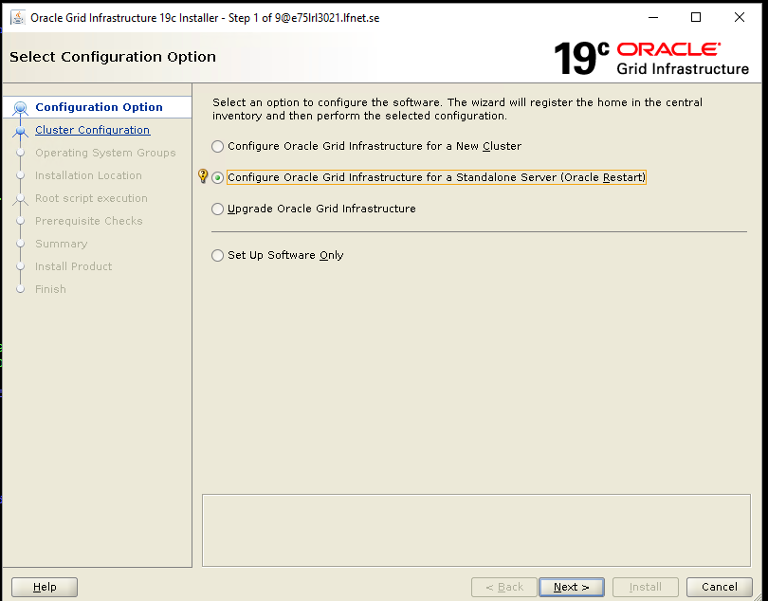

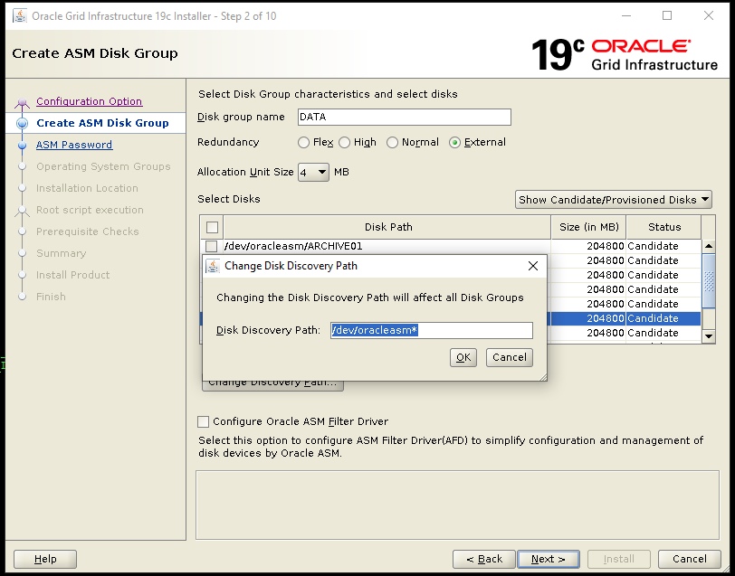

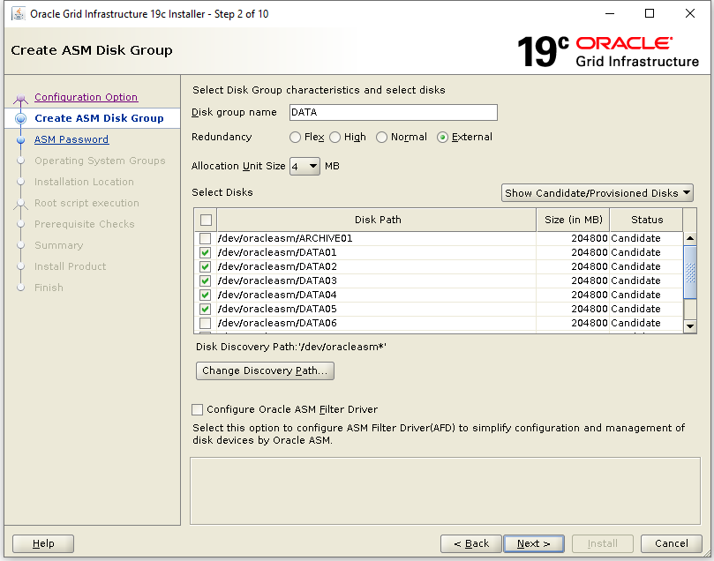
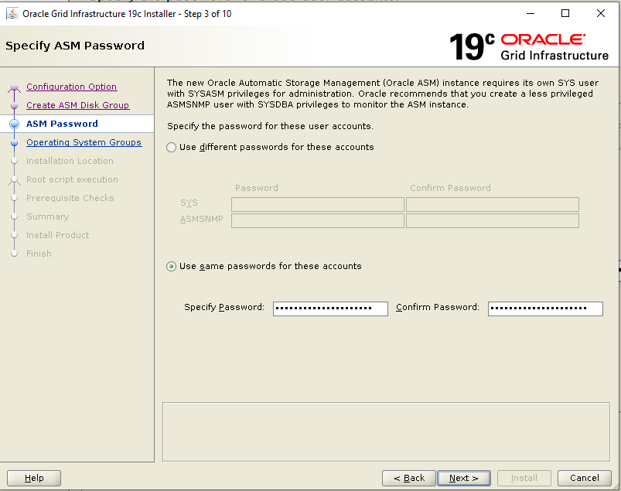
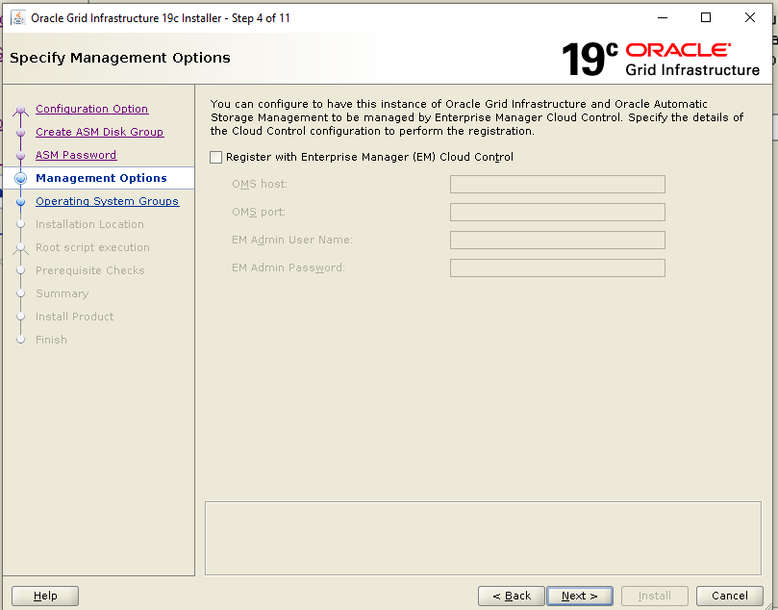

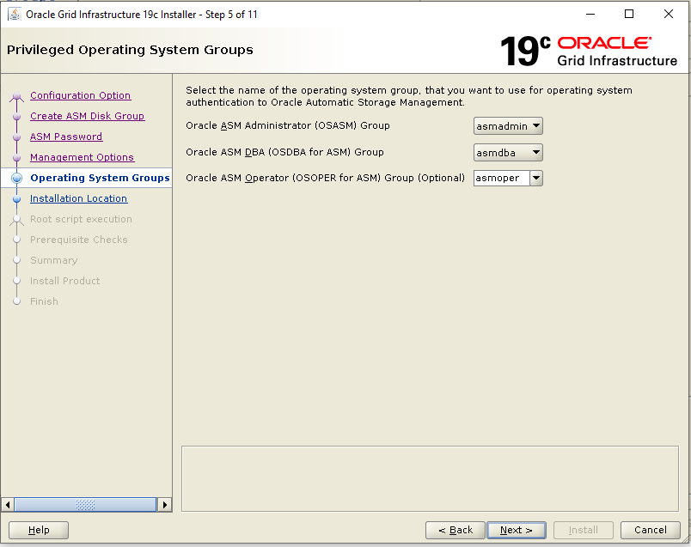
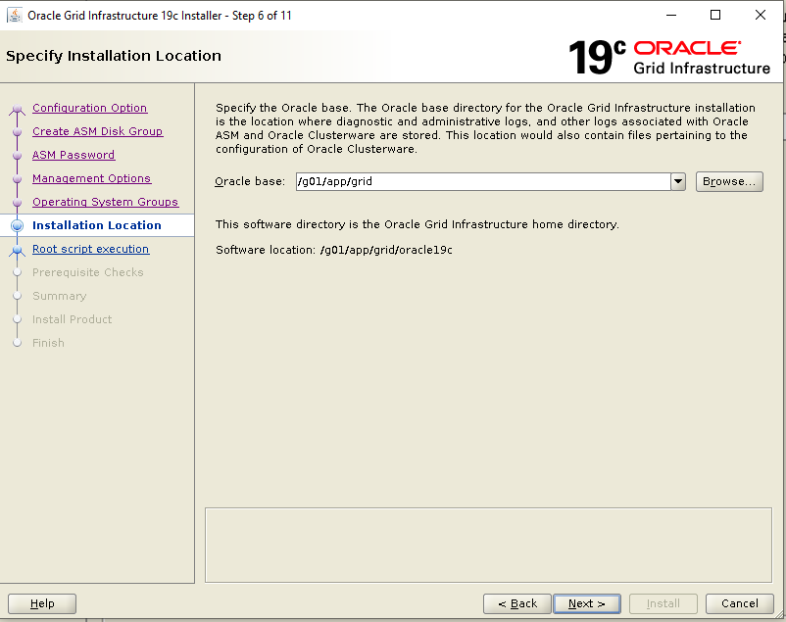

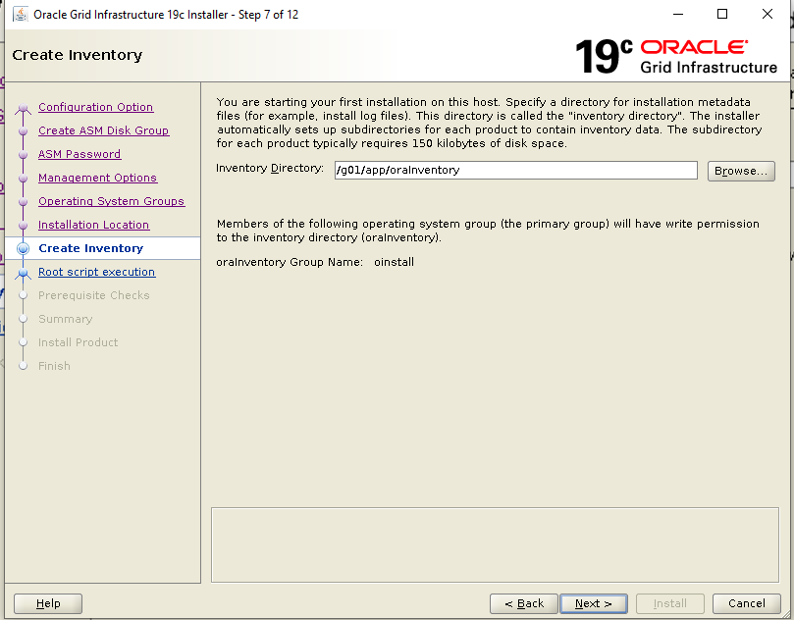
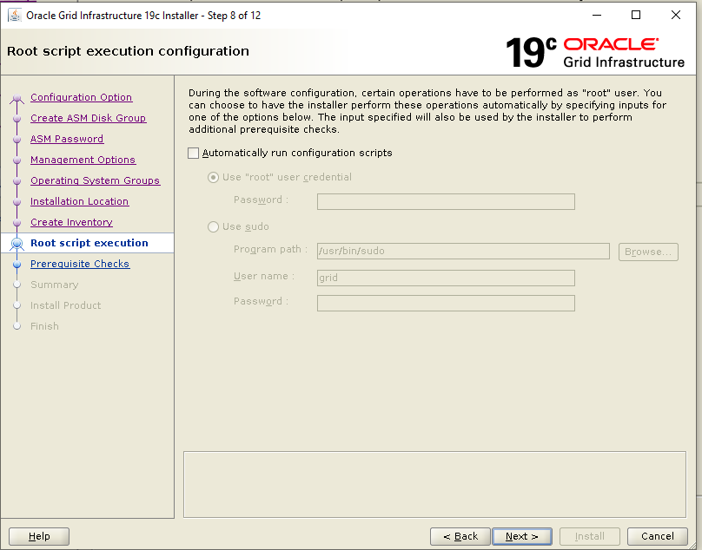

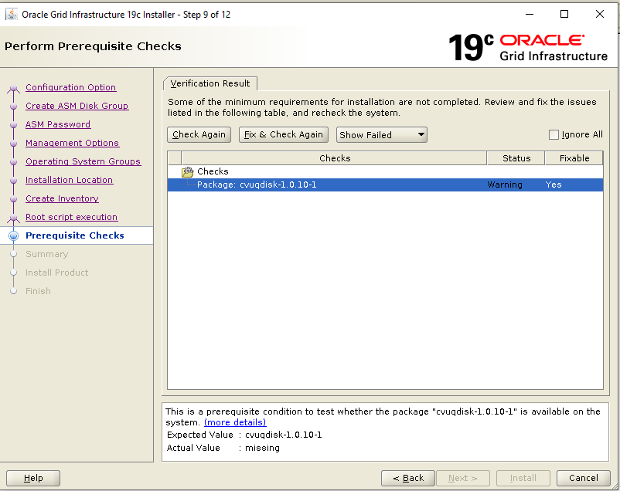
Click Fix and check again, it will ask to run fixup script to resolve.
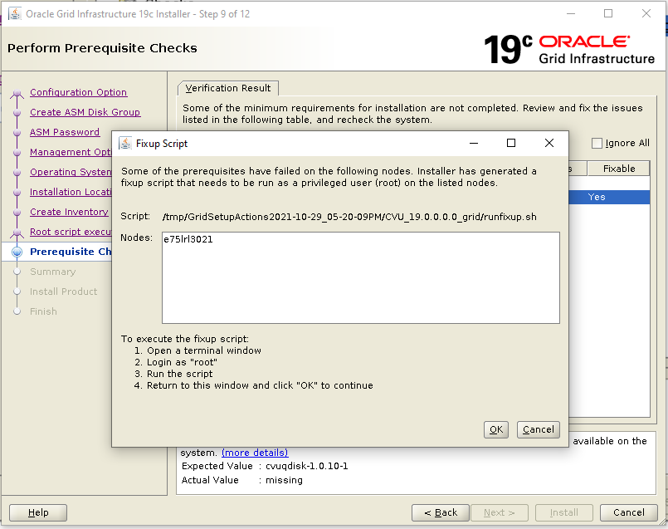

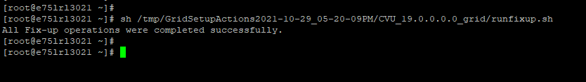

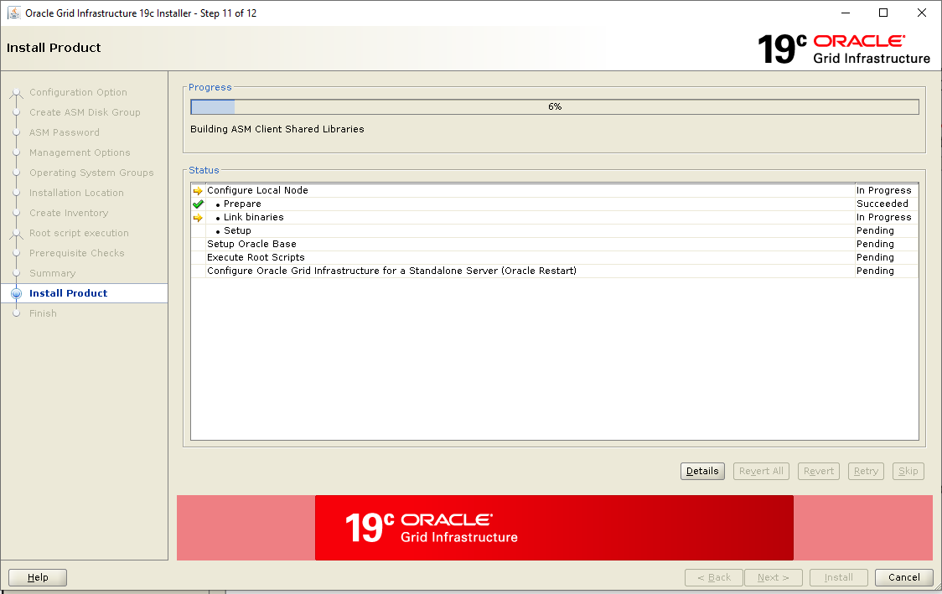

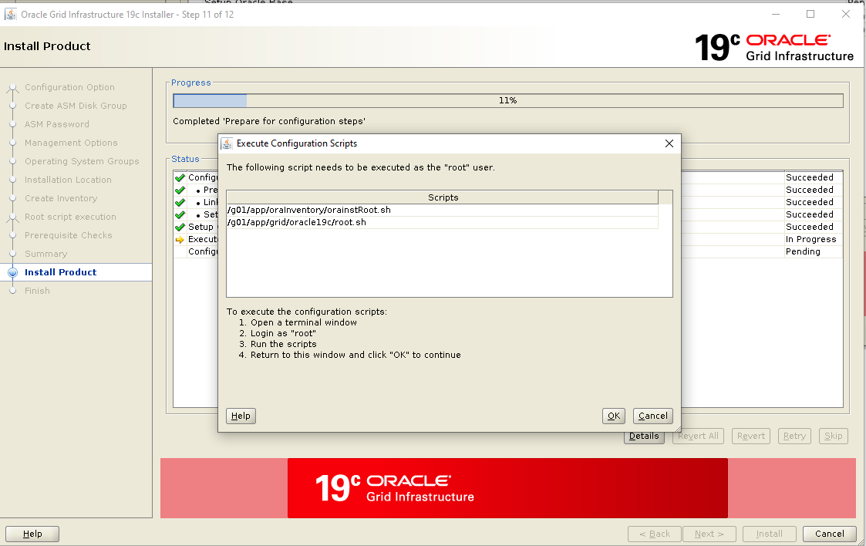
Run both script as root user.
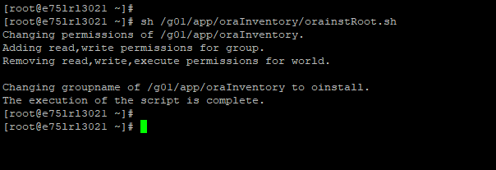

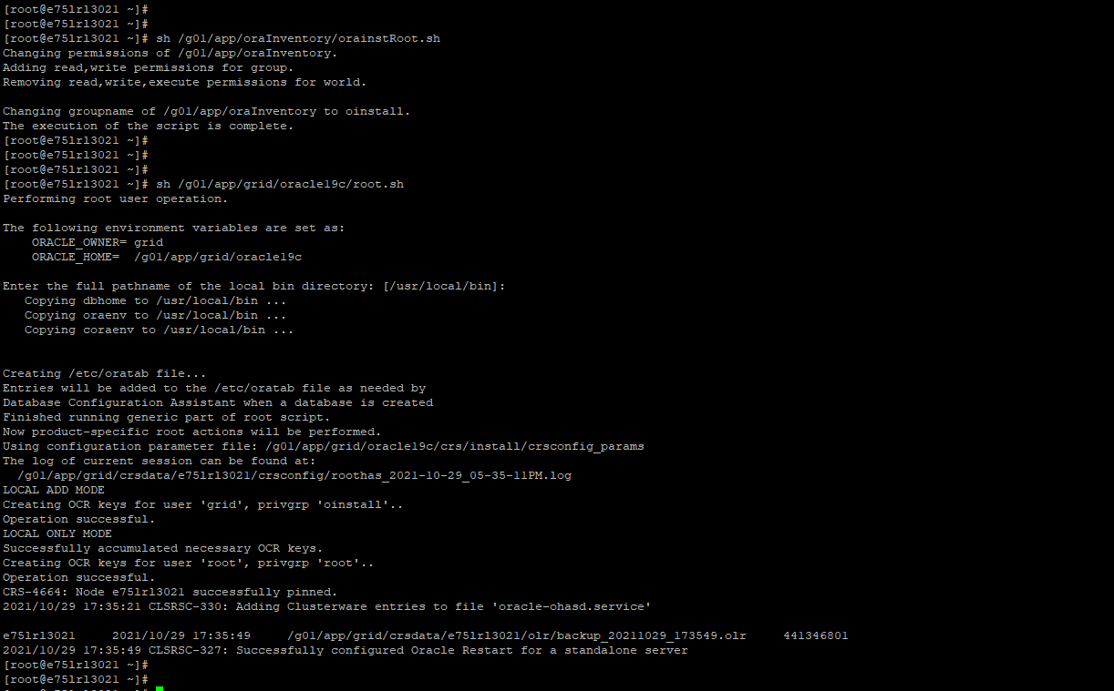
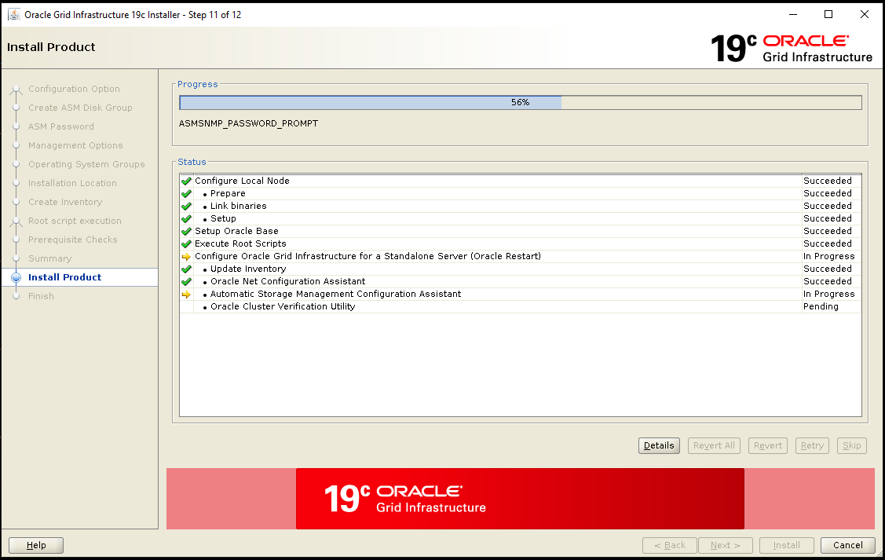

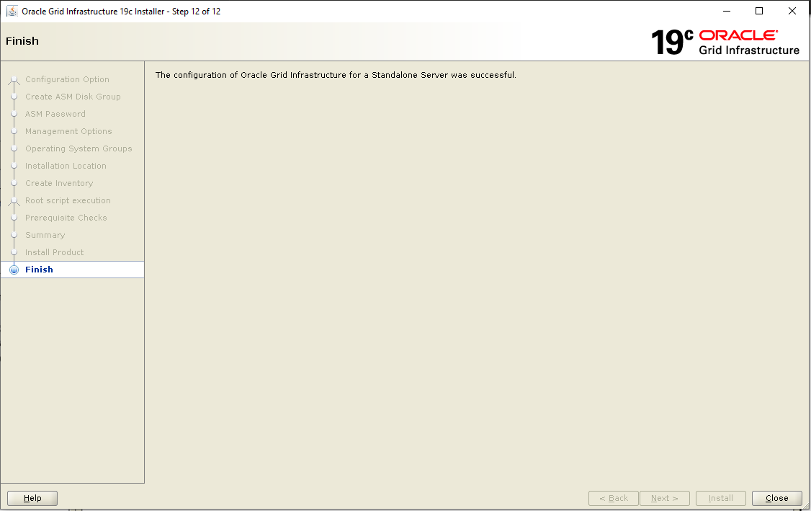
Putty screenshot
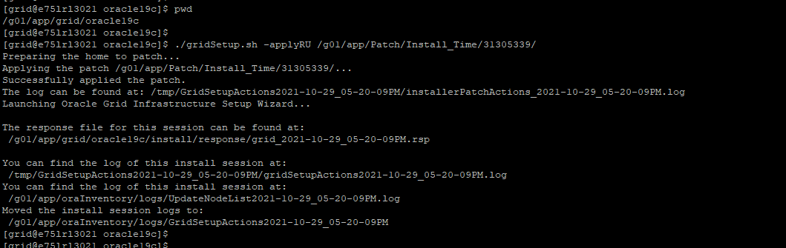

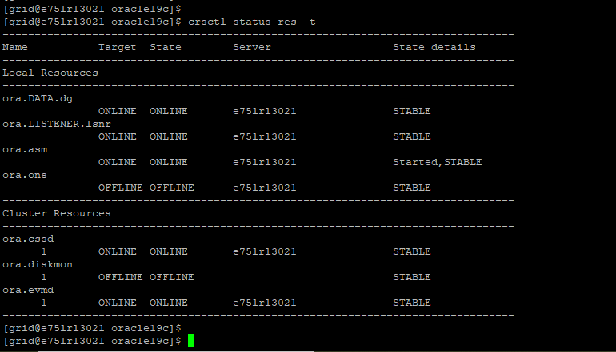

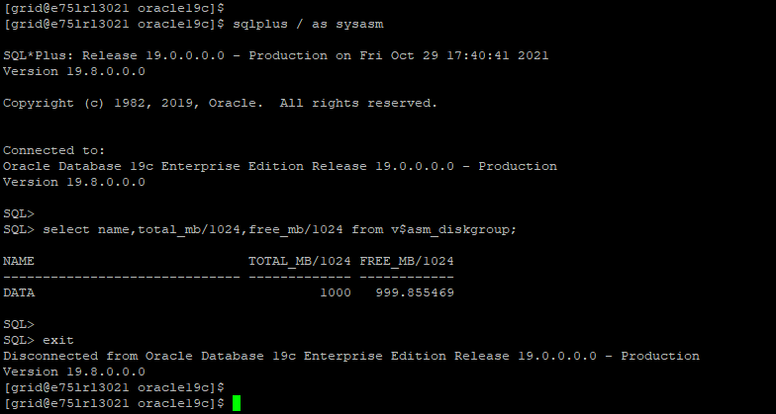
Adding disks to ASM:
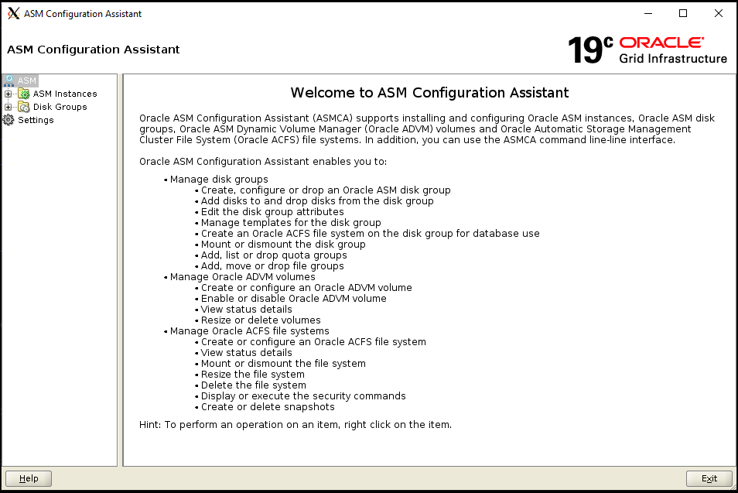

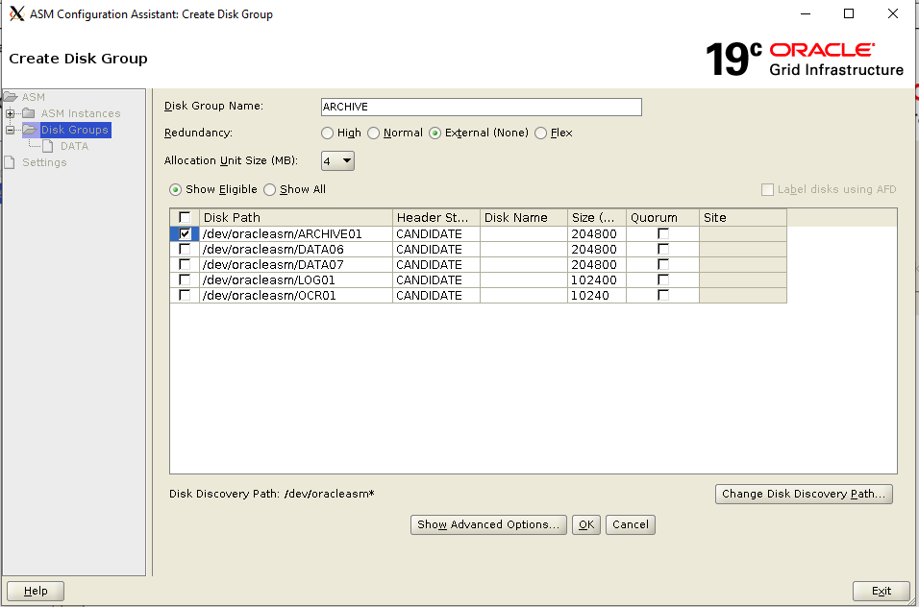

Post install validation

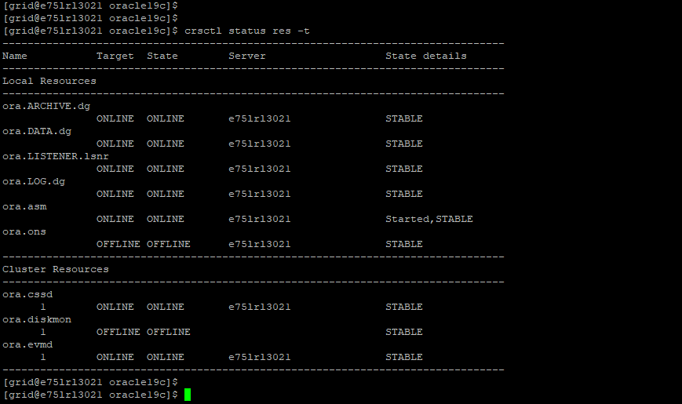

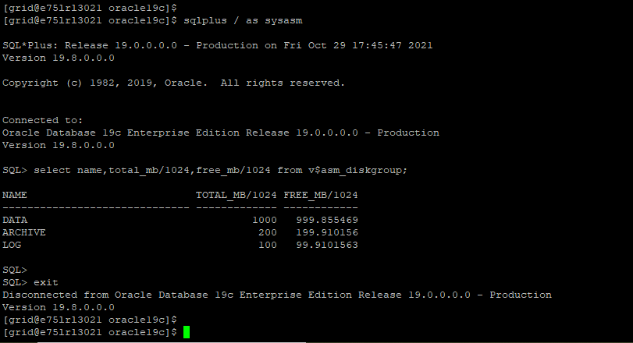

END OF DOCUMENT

